we
opened each other
like

maps

explored,
traced our fingers along
every outline,
got utterly and joy-fully lost
and at last
convinced ourselves
we had
conquered

“you want to have your cake and eat it too.”
“absolutely,” he said

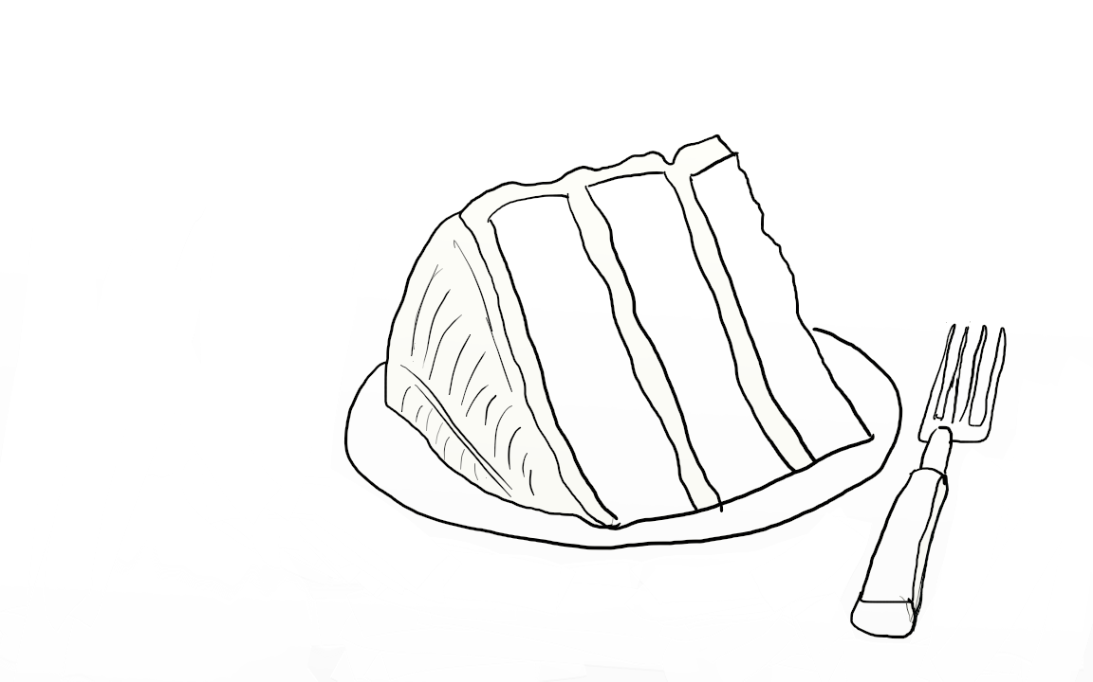

autumn leaves

the leaves that soaked up our
spring (lust,love,loss)
are wilting on their branches

effortlessly falling to the ground or
wind-torn from where they once flourished
to become dirt and dust
(the ground on which we walk)

and much like the memories they hold
(we long to forget)
we break them down with

each
step
we
take

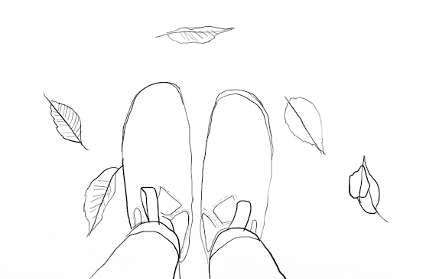
and now
we can hardly remember
the emotions that invaded the buds
burst open their leaves and
filled their pores
(the spring before)

i miss you

z
i
p
p
i
n
g

&

u
n
z
i
p
p
i
n
g

my dress

it’s like i am
standing on the edge
of a great
wide
dark
black
abyss
and you are the torch
on the other side
lighting my way
you said

i am not a light
for lost men
my mind retorted

i will always burn for you
my heart confessed

you make me feel
like a butterfly with
its wings pinned back

